Narrative Writing  After acknowledging what the child is doing well, you might say . . . |  | Leave the writer with . . .
You have told the reader all about (your topic) and that is what writers do when they write an all-about book. But you are writing a story. When you write a story, it is important to tell the reader about the things that happened, telling what happened first, and then next, and next.  One way you can do this is to touch the things in your picture and tell what you did, or tell what happened. Then your reader can know what is happening.  Structure and Cohesion |  | A Post-it that has a picture of a person doing an action. Then you might leave the writer with the words, “What happened?” or “Who did what?”  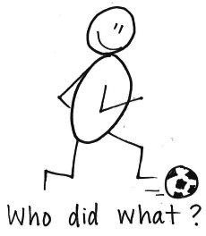
You know what? I’m confused when I read this! I’m sort of going, “What?” “Huh?” And I really want to understand what exactly happened.  The way writers tell stories that readers can understand is they remember what happened first, and then after that. They put what happened into the picture and write it in their stories.  Sometimes, though, do you know what happens? Writers forget to put down some really important information that readers need to know.  It helps to reread your writing and find places where you can say more to help your readers get a clearer picture of what happened.  Structure and Cohesion  continued  Structure and Cohesion |  | I reread. When I go: Huh? (??) I add (^) to make it clear.  Reread:  1. Did I tell what happened first, next?  2. Can I say more?  3. Can I answer readers’ ?s  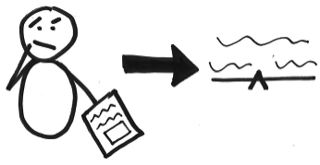
After you write a story, reread it and ask yourself, “Is this confusing? Can I give the reader more information to make this part clearer?”
(Sometimes reading your writing to a partner can help you find the places that might be confusing to a reader.)
Structure and Cohesion
You know what you have done? Instead of writing one whole story, bit by bit, in a book, you have used this book to list the different stories you could write. Oops! There is actually special paper for making a list—see, you could make a shopping list on this paper, or you could list story ideas on it.  But what we are doing now in our writing workshop is we are taking booklets and writing one whole story in each booklet. Let’s try this first idea from your list—a story about swimming in the pool. What did you do right before you got in the pool? That goes here, on page 1. Then what did you do next? Touch this next page and say what happened. Then turn to the next page and think, “What happened next?”  That’s it! That’s how writers write stories.  Structure and Cohesion |  | A Post-it that is divided into two columns, with list paper on the left, and a story booklet on the right. The first page of the story booklet shows a character doing something.  Plan:  1. Think (a drawing of a person, thinking of someone doing something)  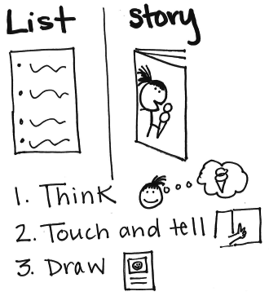  2. Touch and tell  3. Draw each page
You told me a little bit about a lot of things that happened to you. What famous writers usually do, like the writers who write the books in our library, is they decide which one thing is the most important thing they did, and then they write the whole story of that one thing, writing with a lot of details.  Right now, will you look through the pages of your book and think, “What’s the one part of this that is the story I really want to tell?”  You might want to rip off the pages that are about things that aren’t that important. This is the important part, right!  continued  Structure and Cohesion  Structure and Cohesion |  | 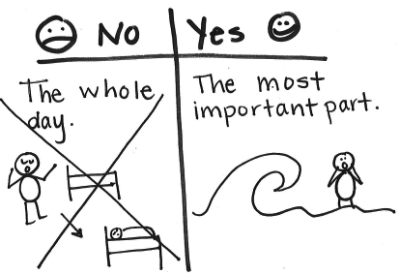
  NO  The whole day | YES  The most important time
Now you know what famous writers do. They take the one most important thing, and they write a whole book just on that one thing. So (grabbing a blank book), what is the first thing that happened when you did . . . Oh! Whoa! How did that go? Who said what? Okay, so it starts . . . Then what?
Can I stop you? You’re on your way, writing a whole book about just the most important part of your story. After this, will you always remember that you aren’t writing about the whole day, you are writing about one thing you did or one thing that happened?
Structure and Cohesion
When I read your story, it is hard for me to picture the whole thing, because you didn’t tell me that much detail about what is going on, about all the people, and the place, and the things that are happening. You just put this little bit of stuff on the paper. You have to tell more so I can picture the story!  One thing that you can do as a writer is that after you are done (and I push back in my chair and shake my hand out, as in a “Whew! That’s done” move) you can pull back in and look at your pictures and your words and think, “What else can I add?”  Think: who? And really imagine who was there with you.  Think: what? And really imagine what you were doing.  Think: where? And add in some details about the place.  Draw it and then write more and more and more!  Elaboration |  | Who? What? Where?  (Remind the writer to use details in her pictures and words.)  You might leave a copy of a page of your writing that has details in the picture and in the words. On top of the writing you can write, with a bold marker pen, “Who?” “What?” and “Where?” Arrows from those words can point to details about the people, the place, the activity.  Alternatively, you can leave a note:  When you are done, you’ve just begun.  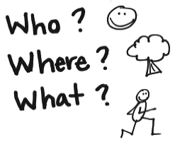
I want to suggest that you are ready to start spending much more time writing, so you write about this much on each page, and write about five pages in a day. That’ll be very grown up.  To do that, you are going to need to do your drawings differently. Instead of trying to tell everything in pictures, you are going to need to tell a lot more things in words.  What I do is I sketch the main thing that is happening on a page, and then after I have drawn just the main thing, I pause and think, “Do I know what I could say?” And if I can think of the words to say, I start writing. And I push myself to write and write and write, telling the whole story in words.  continued  Elaboration |  | A Post-it that contains an icon that shows a piece of paper with a smallish picture space and a larger writing space, with a sample picture and words. The arrow can point to the words.  There can be dotted line arrows, off the sides, going from the picture to the words in a fashion that suggests that content that is first in the picture later gets added into the words.  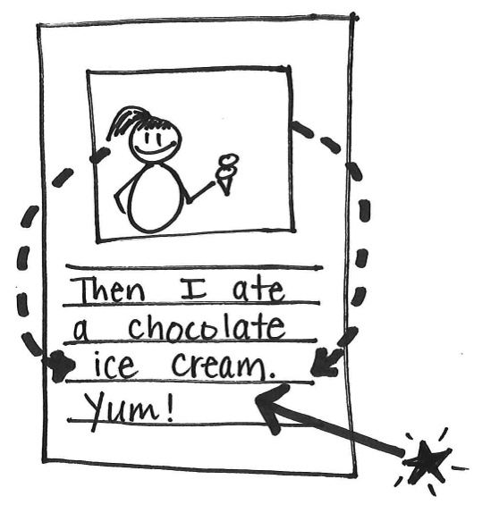
Sometimes after I have written a lot and I feel like my hand is tired from writing, I go back to the picture and I add more stuff into it—but you know what? That gives me ideas for even more that I can write, so then I go back to the writing. I look at what I put into the sketch and make sure everything that I’ve drawn goes into words, too.
After you finish your book, you can come back and look at your picture and make sure that everything you have drawn is in your words, too.
Elaboration
You write like this: (I stand up.) “I went to the park.” (I take one step.) “Then I went down the slide.” (I take another step.) “Then I went on my bike.” (I take another step.)  Your goal needs to be to tell more with each step.  Here, walk with me. (Now, walking in stride) “I went to the park.” (In a whisper) Say more. Which park? How did you get there?  Let’s try it again. (Walking together) “I went to the park.”  Child: The one down the street. We drove there.  “I went down the slide.” (I gesture to add on.)  Child: I went fast.  Elaboration |  | A Post-it saying:  One step (say more!)  The next step (say more)  The next step (say more)  Alternatively:  One step (which one? How? Why?)  Next step (which one? How? Why?)  Next step . . .
You have a lot of talking in your story! In fact, it is so much talking it is too much. It sort of goes like this “Hello. Hello. How are you? I am fine. I am going to the store. Okay, I am, too. Bye. Bye.”  I can hear what people are saying but I can’t see what people are doing.  When you write a story, try to remember to tell who is doing what, where. Then you can add a little bit of talk, but just a little bit.  Elaboration  Elaboration |  | A picture of speech bubbles attached to drawings of stick figure people in action, in a place.  The caption: Who is doing what, where? A little bit of talk.  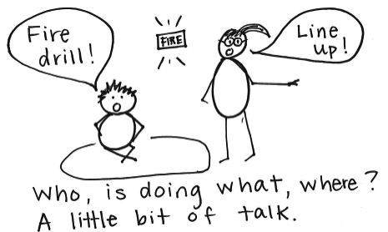
After you write, go back and reread. Right now, will you reread what you have written on this page?  (The writer gets stuck.)  Let me try. (I work at it, and get stuck.)  Let’s try writing another word, and I’ll show you how to write it so you can read it. Which thing do you want to label? Okay, this.  Get started, and let me watch. (The child starts, and hears and records the first sound only. She is done.)  What I’m noticing is that you say the word, hear the first sound, and write that down. But then, you are done! If you want to write so people can read it, you need to say the word again and hear more sounds. Try it.  continued  Language |  | Not: . . . But:  I g t s . . . I go to scl.
That’s it. So after this, when you go to write a word, try to say it one time, record what you hear. Then reread what you have written and say it again. If you get a lot of sounds down, when you come to the place where there are no more sounds, leave a little white space. That will show people you are done.
Language
You are forgetting that writers use punctuation at the end of sentences—like street signs—to tell readers when to stop and take a breath as they are reading. The punctuation signals that the idea is done and a new one is coming.  One thing that you can do to remind yourself to write with punctuation is that once you get to the end of a part of your writing, you should reread your writing. As you reread, listen to when your voice takes a break and think, “What should I use here? A question mark, an exclamation point, or a period?”  Language  Language |  | Did I remember to use punctuation?  . Period  ! Exclamation Point  ? Question Mark
You know, one time I went to a restaurant for a nice dinner. I got there, and I realized I had forgotten my shoes!!!! I had to walk into the restaurant without any shoes on.  I’m telling you this because when you write, you aren’t forgetting your shoes . . . but you do something sort of like that. Do you know what you do? You actually use capital letters in the middles of your sentences for no reason at all! When people saw me walk into that restaurant with just my socks on, they probably thought, “Huh?” and I bet they are thinking the same thing when they see capital letters in the middles of words in your writing.  I think you are old enough to decide that writing capitals for no reason is the old way, and now you are doing the new way.  continued  Language |  | An alphabet chart with lower and uppercase letters.
From now on, remember that writers use capital letters at the beginnings of sentences, for names of people, and for the word I.
After you write a page, you will probably want to reread it to check your capitals. You can be like a detective and search your whole writing to find “capitals that are mess ups.”
If it helps, keep an alphabet chart next to you that has both uppercase and lowercase letters. This can help you remember how to make the lowercase letters if you forget.
Language
One thing that you can do as a writer is to make a list of possible ideas for stories. You can use our chart, ways to come up with ideas for stories, to help you think of all the many things you have in your life to write about! Then you can pick one and write it. When you are done, you come back to the list and pick another!  The Process of Generating Ideas  The Process of Generating Ideas |  | Story Ideas:  1. _________________________  2. _________________________  3. _________________________  4. _________________________  5. _________________________
It is nice to write a couple of stories about the same thing—like Cynthia Rylant has a couple of stories about Henry and Mudge, right? And you have a couple of stories about the park. So you are sort of like Cynthia Rylant.  But one thing about Cynthia Rylant is she doesn’t have Mudge get lost in this story and in this one and in this one. He gets lost in one story, he is in a dog show in another story, and he gets in trouble in another story.  After this, if one story tells about you bike riding in the park, what could the next story tell about? What else do you do in the park?  Great. So, you and Cynthia Rylant are going to be a lot alike, because each of your books will tell about something different.  The Process of Generating Ideas |  | Stories in the Park:  1. bike riding  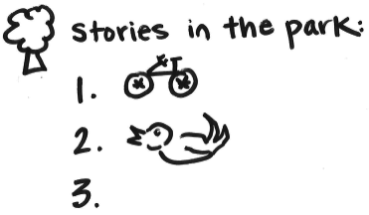  2. finding a baby bird  3. ??  To Come Up with a Story Idea, Think of:  - Things I like to do  - Places I go  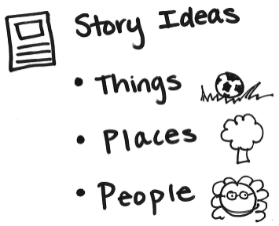  - People I enjoy spending time with
Each day in the workshop you have a decision to make: to work on a piece on the green dot side, pieces that are not finished yet, or start a new piece.  When I look at your folder, I see you have many pieces that are on the green dot side that are not finished! That’s so sad . . . all those unfinished stories. How awful. Don’t you think those stories deserve to be finished?  After this, why don’t you look through the green dot side of your folder and see if there is a story that isn’t finished. That story is probably calling to you, saying “Finish me!!”  So—hear the story’s call, okay, and reread it. Then think, “What happens next? What else was happening in this story? How does it end?”  When you have written the ending, you can reread and revise it like always. Then you can put it on the red dot side.  The Process of Drafting |  | A “Reread me first!” sign on the green dot side of the folder.  Ask:  What happens next?  How does this story end?
What I am noticing about your stories is that they tend to look like this (I make a quick page with a sparse drawing and a single squiggle for a line of print). But I think you, as a writer, are ready to make stories more like this (and I make a quick page with a much more full drawing, and five lines of squiggles, representing print).  What do you need to go from this (I point to the first drawing) to this (I point to the second drawing)?  Right now, will you try a new story and make it more like this (the second way)?  Show me how you get ready to write.  The Process of Drafting  continued  The Process of Drafting |  | A Post-it with “Write long and strong.” or “More, more, more!” written on it.  (As you leave the Post-it, remind the student to use the classroom chart to help her remember ways to add more to her writing.)  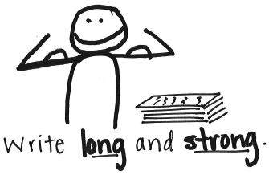
Okay, will you do that again, but this time when you touch and tell the story on each page, will you touch the top of the writing and say what you will write first and then touch the middle of the writing and say what you will write next and then touch the bottom of the writing—on that page—and say what you will write last. Like this:
I put the worm on the hook. (I touch the top of the page.) Now, instead of jumping to the next page—where I catch a fish, I’ll say more. I got worm gook on my fingers. (I touch the middle of the page.) It was disgusting, the worm kept wiggling. (I touch the bottom of the page.)
Now I can go to the next page.
The Process of Drafting
Last night at home, I was looking for your work . . . and I looked (I imitated looking and finding little) and I looked (I looked under the folder, around it) and I looked!! And I hardly found any work.  What do you think has gotten in the way of you getting a lot of work done?  Child: I get stuck a lot.  Well, after this, when you get stuck, you are going to have to get help so you get unstuck—and fast! Because you need to get a lot of writing done.  Let’s make a plan. Today, I am pretty sure you can fill these pages of your book, so I am going to write “Monday” on these pages.  continued  The Process of Drafting |  | Have I added all that I can?  1. Reread and ask yourself, “Did I add all I can add?”  2. Check with a tool: an exemplar, book, or chart.  3. Add more if you can.  4. When you have tried all you can, start a new piece.  The notes “Monday” and “Tuesday” suffice as a deadline.  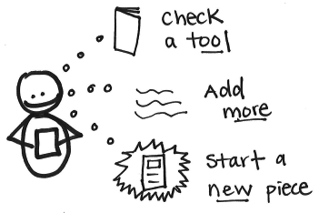
Tomorrow, what do you think you can get done if you don’t let yourself get stuck? So let’s label those pages “Tuesday.”
Now . . . you have a lot to do. So will you remember, touch the pages and say aloud what you are going to write, then come back and write it. And if you get stuck, ask for help. Come get me. Because you have to meet these deadlines.
The Process of Drafting
The Process of Drafting
One thing writers do when they finish their last page, is they reread the whole book and think, “What else can I say? What else happened in this story?” They turn back to page 1 and use their pictures to help them imagine more and use the movie in their mind to capture more details on the page.  The Process of Revision |  | Revise:  Make a movie in your mind.  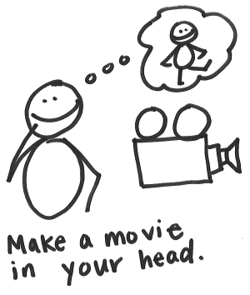
When writers revise, they don’t only add more to help show what is happening and how they feel. They also take things out that don’t belong or make sense in their story.  One thing you can do as a writer is to revise and take things out that don’t belong. One way to do this is to reread and ask yourself, “Does this belong in my story? Does it make sense?”  The Process of Revision |  | Revise:  1. Does it belong in my story?  2. If no, X it out.  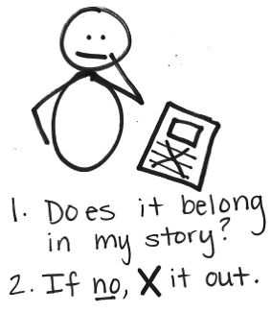  Revise:  1. + add information  2. – take out information
Writers revise by adding more. They also revise by thinking about showing the important part of their story. They think, “What do I really want to show and tell my reader?” And they revise accordingly.  One thing that you can do before you try to add on to your pieces is ask yourself, “What is the most important part of my story?” One thing writers do is to take off the pages that aren’t about that part and add more pages to tell about that important part. They try to add their details about the important part of the story.  The Process of Revision |  | Is my small moment about the important part? Or does it have unimportant parts to take out?
  Important Parts | Not Important Parts
One thing that writers do when they have revised their stories as best they can is that they reread their pieces and edit their mistakes. They fix their spelling and their punctuation the best they can.  One way to do this is to reread your story carefully, from start to finish, a couple of times. You might first reread it to make sure that there aren’t any missing words and fix up any easy errors that stand out, like ending punctuation you missed or spelling that you wrote too quickly.  The Process of Editing |  | Reread and Edit:  - Find missing words  - Fix spelling  - Check punctuation
Sometimes when you are editing, there may be times when you feel like you can’t find any errors! That’s when you really have to challenge yourself.  One thing that you might do as a writer is to choose a couple of words to think more about—ones that you aren’t sure if they are spelled correctly. You can choose them and think, “Are there other ways to spell this word? How else could it look? Is there another way to make some of these sounds?”  You might try the word a few different ways to see if you can find a better spelling.  The Process of Editing |  | Try Your Spelling a Few Times:  1. _________________________  2. _________________________  3. _________________________

Information Writing  After acknowledging what the child is doing well, you might say . . . |  | Leave the writer with . . .
You’ve got a nice start to a story here. You are telling one thing that happened—you took your dog for a walk.  But actually, right now we are writing all-about pieces. The pieces we are writing now aren’t stories; they are all-about nonfiction books that teach people true stuff about a topic. One thing that you want to do as a writer is to teach your reader the information about the topic, rather than tell them a story about one time when something happened to you. To do this, one thing you might do is to name the topic and the information that you can teach your reader. Say the list across your fingers, and then you can draw and write it across pages.  Structure and Cohesion |  | Teaching Book:  - Name a topic  - Teach information  (You may leave the writer a couple of nonfiction books from the leveled library to help her remember what an information book is.)  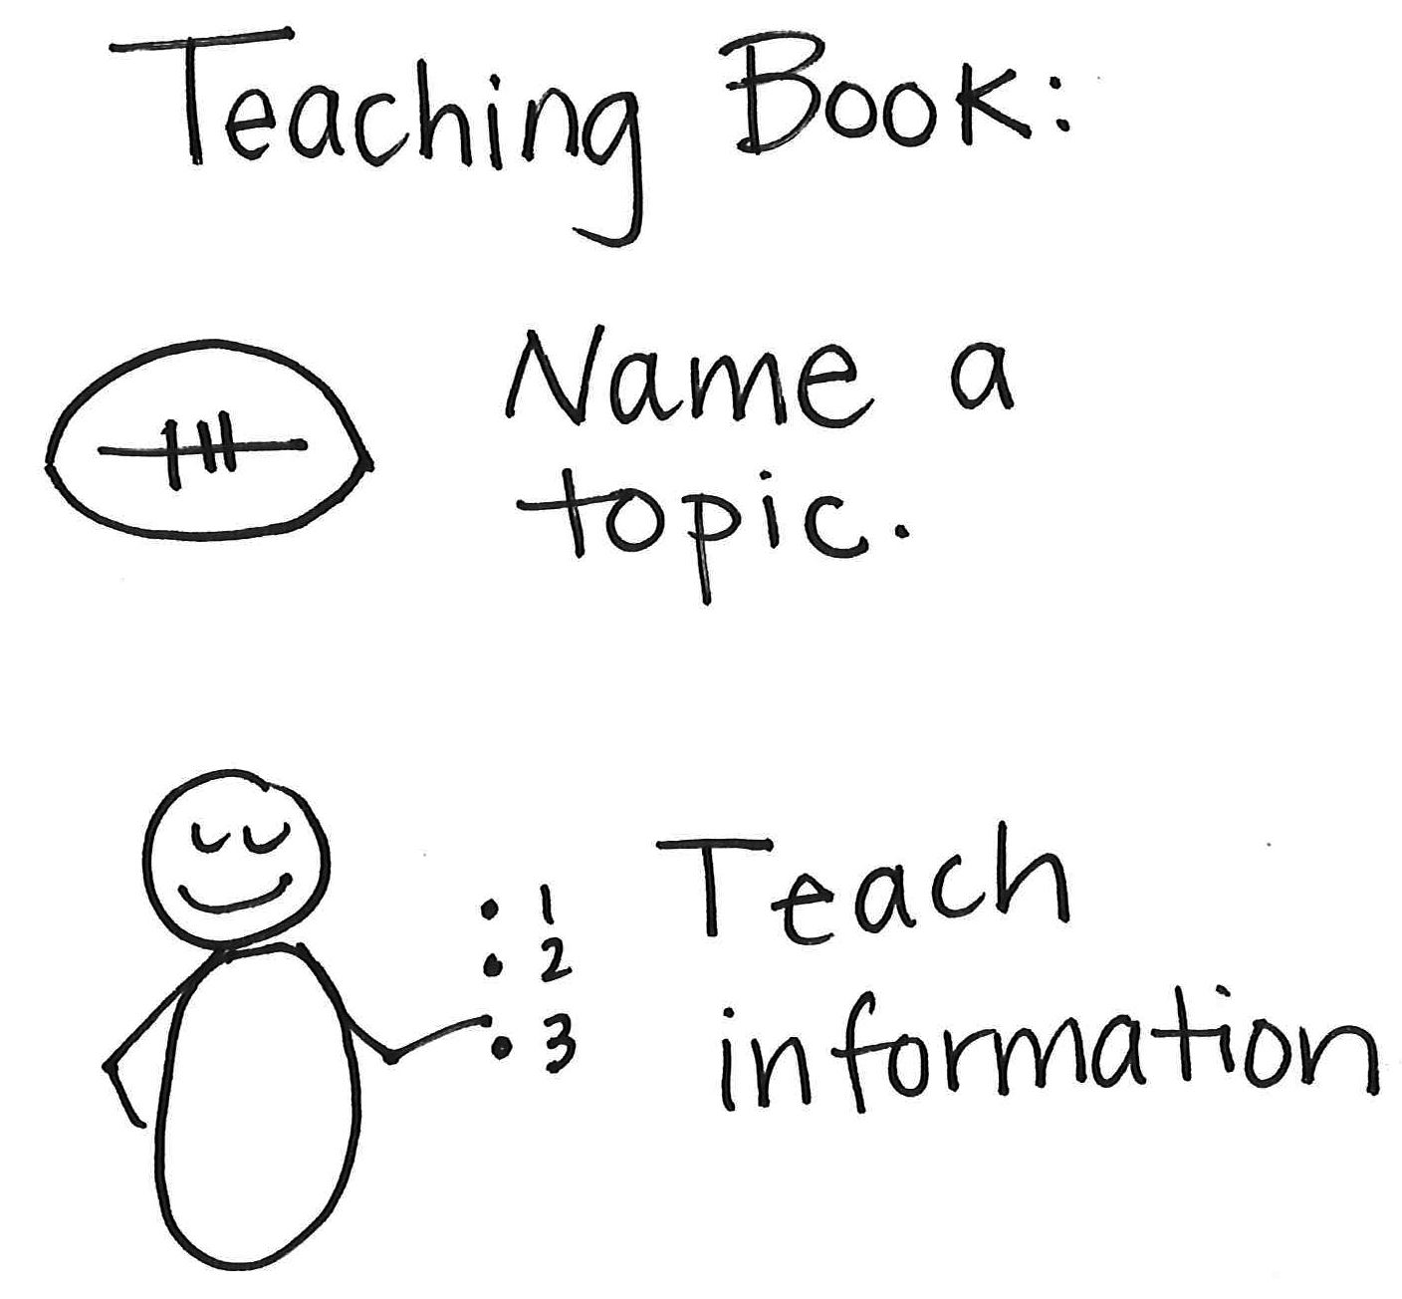
You know what I think is happening? You have so much to say that when you pick up your pen, you just start writing right away, without thinking, “Wait. How will my book go?” I’m glad you have a lot to teach, but now that you are getting to be almost seven years old, I think you are old enough to do what professional writers do—the people who write the books in our library. When they sit down to write a book, instead of just starting by writing one thing that comes to mind, they say, “Wait a minute. How will my whole book go?” and then they plan out what they will write about on one page, and on another page.  continued  Structure and Cohesion  Structure and Cohesion |  | Wait! How will my whole book go?  1. Table of Contents  2. Pictures  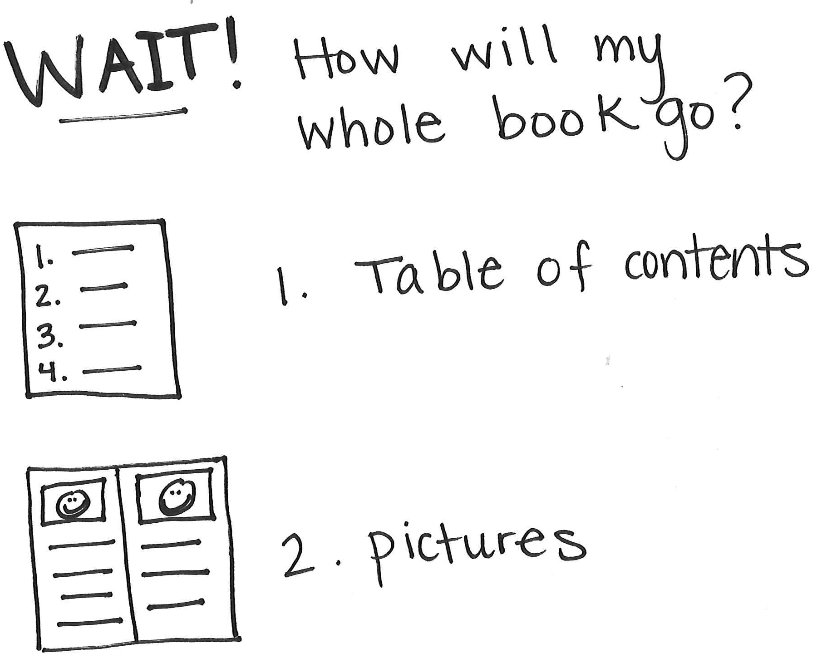
Are you willing to try that planning while I am here to help? Yes?! Great. And after this, whenever you go to write a book, remember to do like the pros and to say, “Wait! How will my whole book go?”
Then you can plan by making a Table of Contents, or by sketching what goes on each page.
Structure and Cohesion
I want to ask you to do something. Pretend the phone is ringing, and lift up the receiver, okay? “Ring, ring.”  Structure and Cohesion  The child says: “Hello?”  “And then he stopped seeing his patients. He just wrote them letters and said he was too old to be their Goodbye.”  I stopped. How would that be as a phone conversation? Pretty weird, right? I agree. It would be weird because there wasn’t any start to it, or any finish. There was no introduction, no overview, and there was no closing.  I am telling you this because your writing seems to go like that a lot. Your book just starts in teaching something about your topic. There isn’t any place where you talk to the reader and you tell the reader what the whole book will be about and why you have written it, that sort of thing.  continued |  | Starts and Endings:  - What am I writing about?  - Why is it important?  - What do I hope you learn, think, feel?  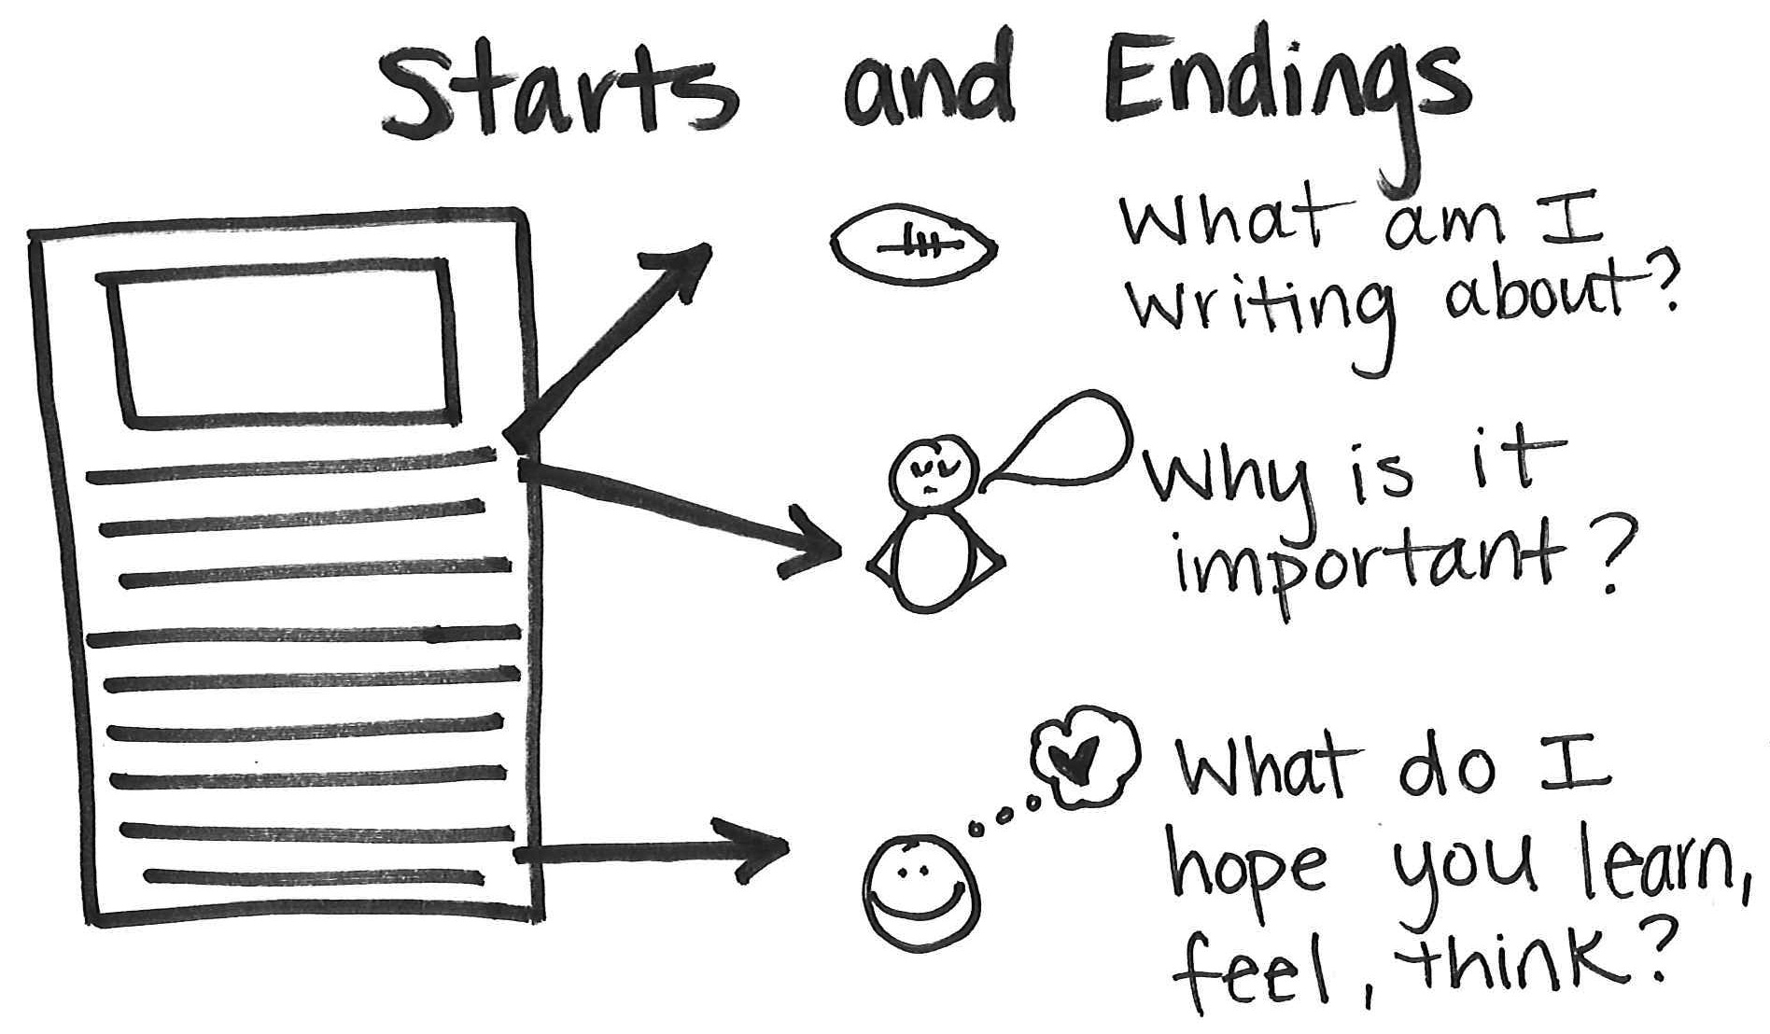
Do you want to study the way other people start books and see if you want to begin starting your books in a more usual way? If you decide to change the way you start books so it is more usual, who knows, you might end up thinking about the way you end books as well.
* * *
One thing that writers do to end their information book is they think about the topic and why it is important to know and learn about. Sometimes writers tell their readers what they hope for in the future.
Structure and Cohesion
Structure and Cohesion
When you are teaching information, it is important to teach your reader lots of information—on every page, you teach the reader some information.  One way that writers think up details to teach is by thinking, “What would readers want to know about my topic? What questions would they ask?” Then writers answer those questions.  Elaboration |  | Page 1: Information  Page 2: Information  Page 3: Information  Ask and Answer Questions:  Why?  When?  How?  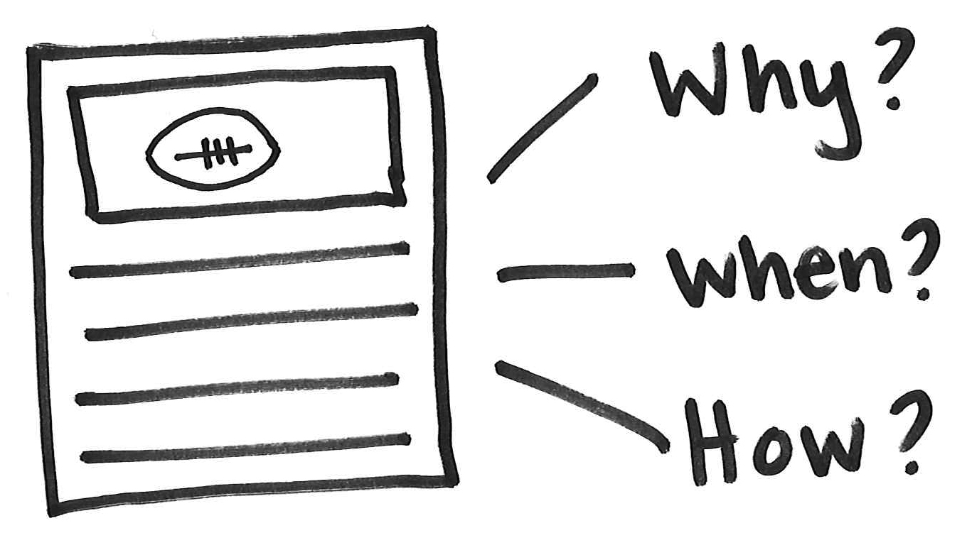
You have gotten really good at comparing, haven’t you? You compared here, here, here, here. I am glad you have learned to do that, and you are right that practicing so much has made it so you will always, after this, remember that one way to elaborate on a fact when you are writing an all-about book is to make readers really think about that fact by comparing it to something else.  Elaboration  continued  But here is the thing. You are actually doing that one thing—comparing—too much. In fact, you are doing it way too much.  As you become sort of like a professional writer, you are going to want to go from writing like a kid to writing like a pro. You know how little kids, when they learn to use exclamation points, start using them all the time . . . Yeah, they sometimes use whole lines of exclamation points. |  | A mini chart from the classroom to help her remember and think about how she can say more in her writing.  You may decide to leave the writer with a Post-it that says, “How else can I describe or teach about my information?” You will want to tell the writer to use the chart in the classroom.
Well, you are sort of doing the same thing with comparing. You are overusing it.
But you are right to want to elaborate, to say more, about a fact before moving on. It’s just that the best way to elaborate is to have a little list of different ways you can do that, and then to draw on that whole list of ways. Would you and your partner be willing to work together and start a short list of different ways to elaborate? Then we’ll share this list with the rest of the class and get their ideas, too.
Elaboration
You know what, your writing hops back and forth from one topic to another to the first again . . . like it is about bears, then dogs, then bears again, then dogs, then rabbits, then bears . . . it is sort of crazy! Usually what a writer does is she puts all the pages that are about one thing together, with a title, and all the pages about something different together, with a title.  Maybe you want to use jaws (the staple remover) to take your book apart and see if it can get divided into three books. And another time, when you are writing a book and you think of a whole different topic to write about—get another book. Don’t smoosh it all together in one.  Elaboration |  | (One topic) (one topic) (one topic)
When writers write fiction stories, they make up stuff that isn’t true. But you are writing non-fiction now, or true books. After you write a book, you can reread it and think, “Is this all true?” And if some of it isn’t true, then you take it out.  Elaboration |  | Reread:  - True information?  or  - Not true?  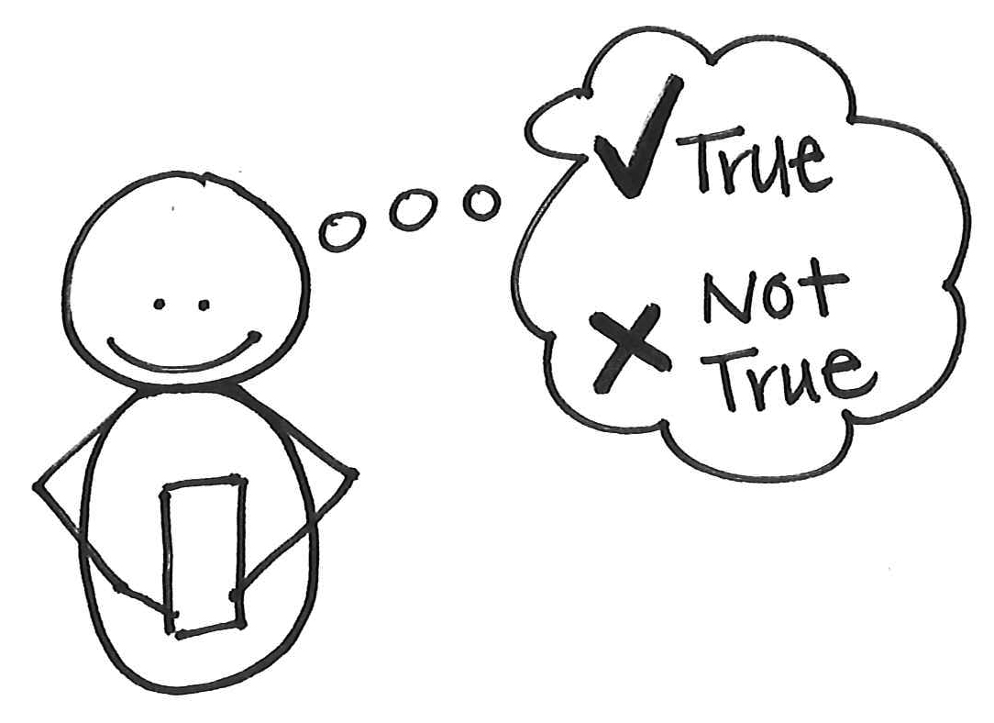
As you are writing, will you think more about how you are using end punctuation to talk to your readers? Reread your writing and think which end punctuation you need. You are tending to use only periods, and actually you could be using exclamation points and question marks as well.  Elaboration  Language |  | Reread and Edit for Punctuation:  . Period  ! Exclamation Point  ? Question Mark
When you write, you want to use all that you know about writing words. Using all that you know will help you as well as your reader to read back what you have written and taught in your book.  Language  One way that you can help make your writing even more readable is to work on getting more sounds in your words. After you put a letter down for your word, keep saying the word slowly. Listen for the next sound. Slide your finger under the letter you wrote as you listen to the next sound. Keep your alphabet chart here to think about what other letters you hear.  Language |  | You may decide to have the student use his word sorts to help him study his spelling. Remind the writer to take out his sorts to remind him about the features of phonics that he is studying and working on. These could be in an envelope that he keeps in his writing folder if you make him a set.
When you are teaching information in your books, remember that the reader also wants to be an expert. Usually experts know really important words that have to do with their topics. As a nonfiction writer you want to use these words and also teach them to your readers, so that they too can be experts.  As you are writing, one way that you can do this is to reread and think about the information and ask yourself, “Did I use all the special words that fit with this information? Is there a better word or a more specific word that fits with this topic that I can use?” |  | A Post-it with a few keywords to reread and think about.  You may write on the Post-it, “Look for places to use special words. Think about what important words fit with this topic.”  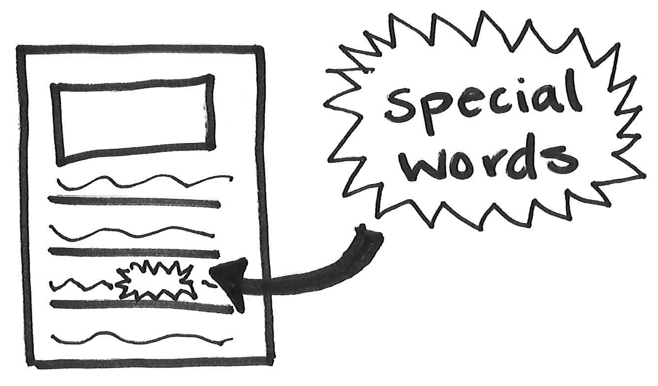
Sometimes it seems like you are trying to write information books about topics that you don’t know too much about. That doesn’t work. Writers write books about things that they know and care a lot about so that they can teach others. They usually choose topics that they have a lot to say about and that they think is important for others to know.  There are many ways to come up with a topic to write about. You can think about your own life. What are things you have, places you go, or things you do that you think other people should care about as well? Let’s make a little list.  Then you can start thinking about the chapters or parts of your book to see if you have a lot to say about the topic.  The Process of Generating Ideas |  | To come up with an idea for an information book, think:  - Things I have  - Places I go  - Things I like to do  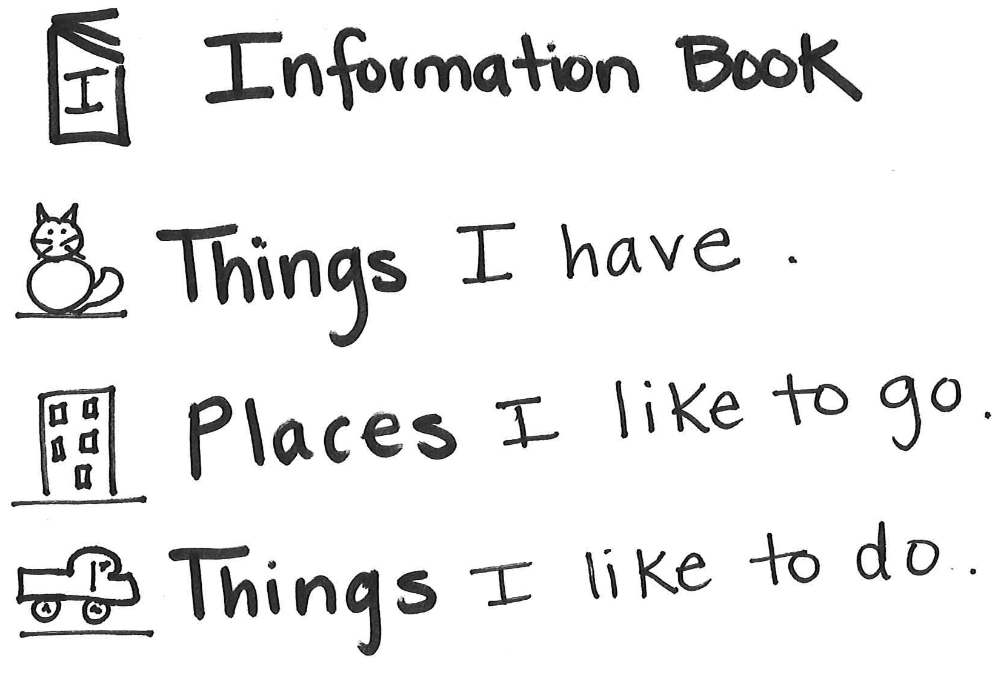
You seem to always start your books by writing these lovely, full pages that teach so much, but then after a bit, your pages get to be like this, and this.  One thing that can help is to set a goal for how much you will write on a page. Make an X at the bottom of the page. See if you can write to that X. When you get there, set a new goal! This will help you get more and more ideas down on the page!  The Process of Drafting |  | - Step 1: Set a goal. Make a star or an X on the page.  - Step 2: Write to the goal as fast as you can.  - Step 3: Set a new goal.
Writers draw and write with details to teach the reader. Sometimes you may spend more time on your drawing because you see a lot of details that you can add. Remember, while writers are drafting, they are trying to get as much information into their words as possible. Drawings can help the writer see more to say.  I want to teach you that when you are drafting and revising your information books, use what you draw to help add more information to your words.  If the details don’t really help you add more information, wait until the end of the writing process when you will publish to color and illustrate.  The Process of Drafting |  | Use your picture to write all that you see.  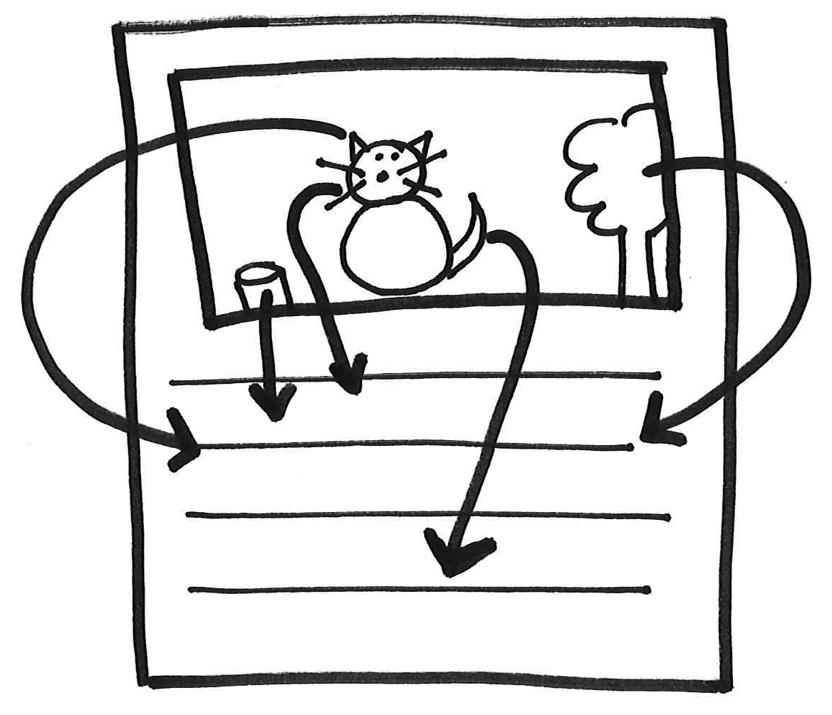
Information writers revise as well. They use the same types of tools as other writers to help them revise their piece.  Sometimes, studying a mentor text can help you find and think about what you may want to add or change in your own writing. One thing that I want to teach you is that you can study books and think, “What did this author do that was powerful in his writing? Can I do the same thing with my topic?”  The Process of Revision |  | Provide a mentor text to help remind her to study books to find ideas for her writing. On a Post-it, write, “What did this author do that I can do?”  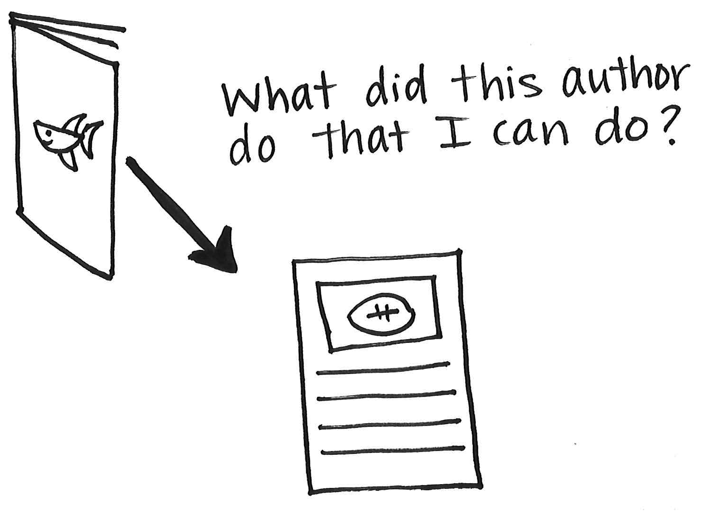
You are really good at adding things as you revise. Sometimes you add details, and sometimes you add things that will help make it so your writing makes sense. That’s great. Congratulations.  Now—can I teach you the next step? The next step as a reviser is to reread your writing, knowing that sometimes what the writing needs is for you to add, and sometimes the writing needs you to subtract! Like, if the book is called My Hamster and you get to a part that goes on and on about your turtle . . . what would you need to do? You are right! Subtract. And what if you say, “My hamster has a tiny tail” at the start of your book and then at the very end you say, “My hamster has a tiny tail.” What if you repeated yourself by mistake? You are right! You’d subtract.  The Process of Revision  continued |  | Writers Revise by:  - + adding (details, answers to readers questions)  - – subtracting (parts that don’t belong, repetition . . . )  * improving (making the words better, making writing interesting)
Writers even do one more thing when they revise, they sometimes try to write the same thing with better words, or more excitement—revising not to add or subtract but to improve. If you ever do that, would you call me over?
The Process of Revision
When you reread and edit your writing, it should take a little bit of time. You shouldn’t feel like it was super fast. Editors are detectives, looking for mistakes that are hiding!  One way to edit really carefully, like a detective, is to reread your writing many times, out loud, and slowly. Place your pen right under the words as you are reading. You might even reread a page a couple of times, just to be sure that no mistakes are hiding. Use the checklist in our room to help remind you of what kinds of things to be looking for as you are rereading.  The Process of Editing |  | Reread and Edit:  - Spelling  - Punctuation  - Capitals  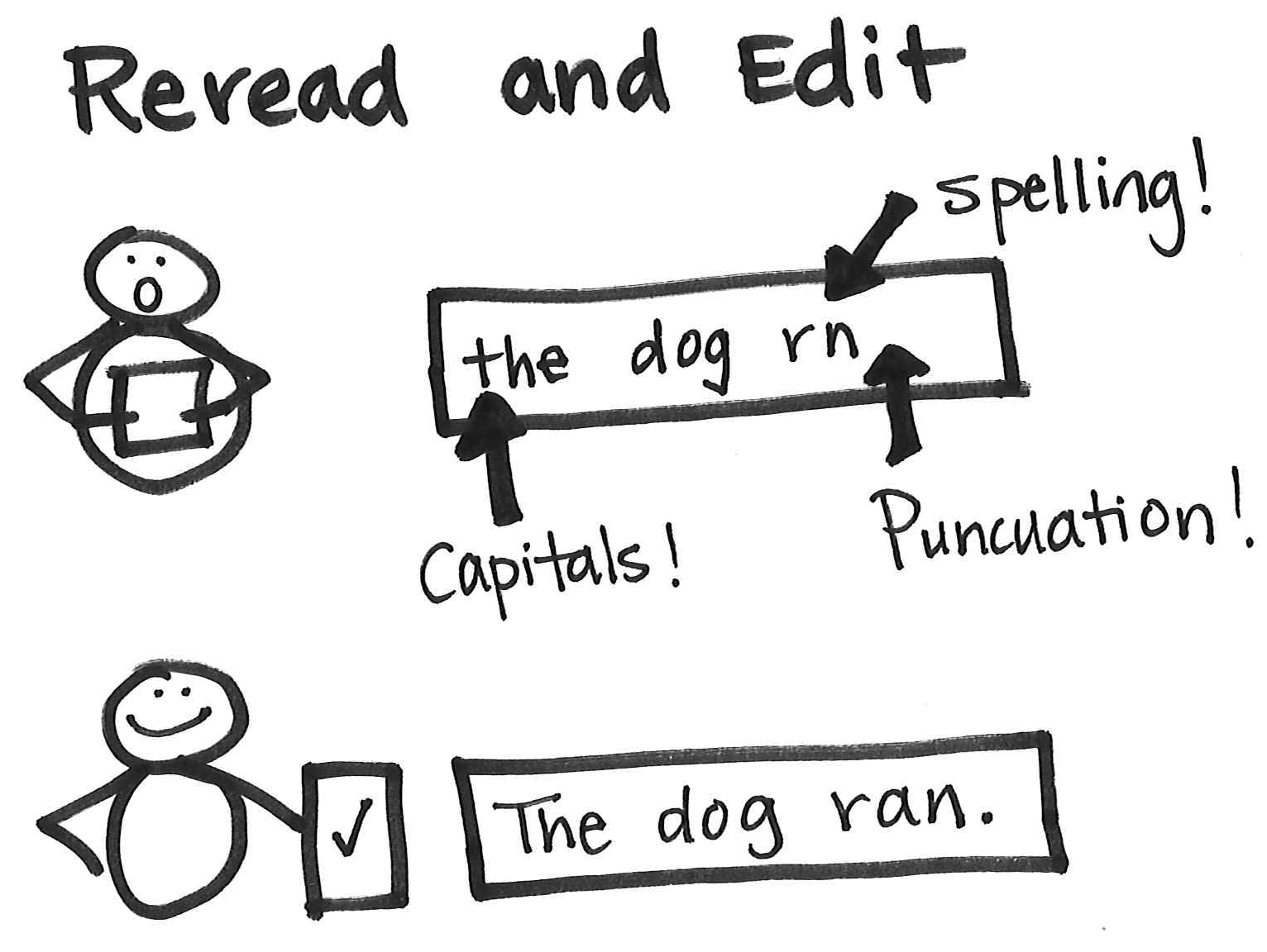
Writers reread and think carefully about where to place end punctuation. They think, “Does that sound right? Can I understand what I am teaching?” Sometimes reading it to a partner can help uncover the errors.  After you find a mistake, you can change it.  When you change it, though, check it the same way, “Does it sound right? Do I understand what I am teaching?”  The Process of Drafting  The Process of Editing |  | Check End Punctuation:  - Does that sound right?  - Can I understand what I am teaching?

Opinion Writing  After acknowledging what the child is doing well, you might say . . . |  | Leave the writer with . . .
You are writing a story—it tells what happened to you first, next, next. You want to be the kind of writer who can write different kinds of things. Like if you were a jewelry maker, you’d be glad if you could make pretty pins, but you’d also want to know how to make other things, too. And you wouldn’t want to start off making a necklace and it looks like a little dog with a pin on the back! Well, today, you sort of did that. You started out making not a necklace but some opinion writing to change the world and you ended up making . . . a story again.  When you write opinion pieces instead of telling a story, you tell people how you feel about things in the world—things you really like or things you want to change. Then you say, “This is what I think, and this is why.”  Structure and Cohesion |  | Story: I did this, and then this (or: She did this, then this.)  Opinion writing: I think this. Here’s why! You should think this way too.  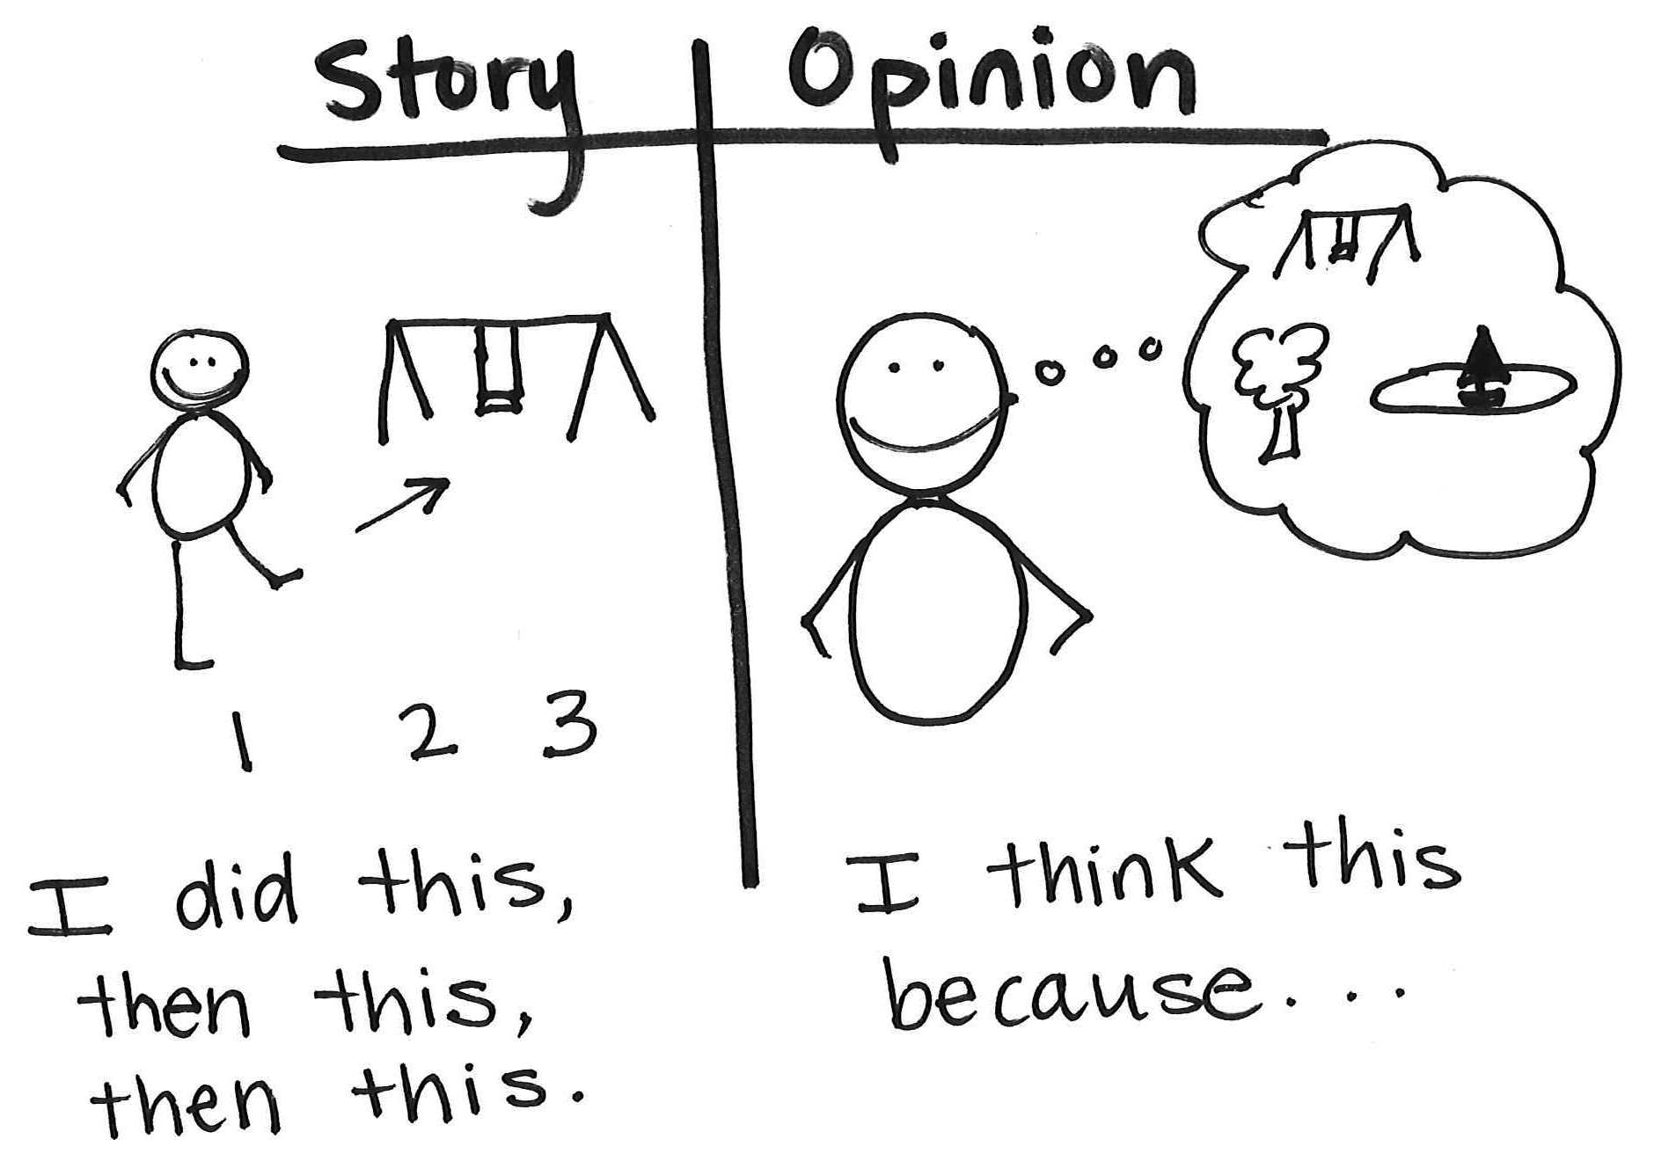
Writers plan their books. They think about how they are going to organize their information. Writers think about each part, from the beginning to the end.  One way that you can work on the introduction of your book is to tell your readers about your topic, your opinion, and why they should read your book!  Structure and Cohesion  Structure and Cohesion |  | Things to Include in an Introduction:  - Your topic  - Your opinion  - Why?  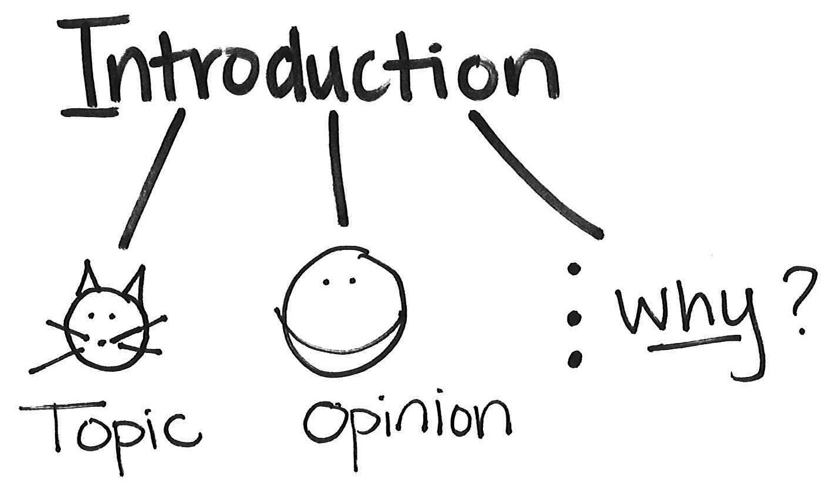
Writers try to organize their information in their books. Writers talk about each part of their idea as much as they can before they go on to another part of their piece.  One way that you can organize your information and connect the different parts of your piece is to tell all about one piece of information. Then you can think to yourself, “Do I have another example?” Or you can say to yourself, “Also, another reason might be . . .”  This will help you not only connect your ideas, but it will also help you say more.  Structure and Cohesion |  | - “One example is . . .”  - “Another reason . . .”
Writers try to give their readers lots of information about their topic and their opinion so that readers begin to believe and understand the writer’s feelings about the topic.  One way you can add more is to ask and answer the question, “Why?” “Why do I have this opinion? Why is this important?”  This can help you say more.  You can also tell an example, or tell what is bad about the other side of your opinion.  Elaboration |  | Say more:  Why do I feel this way?  Why else?  What’s bad about the other side?
One thing that you can do as a writer is to study your own best writing—and then try to do that best writing on every page.  I say this because on this page, you used a very fancy technique to elaborate . . . let me show you . . . So what do you think you should be doing on this page? And this one?  Structure and Cohesion  Elaboration |  | Study great writers, like you!!  What did I do on one page (in one part) that I can do on every page (in every part)?  Page 1:  Page 2:  Page 3: I compared two things!!  Page 4:
Right now, will you tell me a bit about this? What do you think?  continued  Oh . . . and can you explain why you think that?  You know what—one of the most important things that writers learn is that great writing sounds a lot like the writer is talking to the reader. Let me say back what you just said to me because these words are full of what people call voice. These are the words you should put onto the page when you write. Listen . . .  I’m telling you this because the way you wrote this book, and this one too, and this one, it feels like a machine could have written that. It doesn’t sound like you.  Elaboration |  | At the top of each page, draw a face with a speech balloon coming out of the mouth to remind the writer to first say it to someone, trying to talk like she really cares about it.  Remind the writer that you’ll check to see if it actually sounds like the writer (not a machine) wrote it when you read her writing.  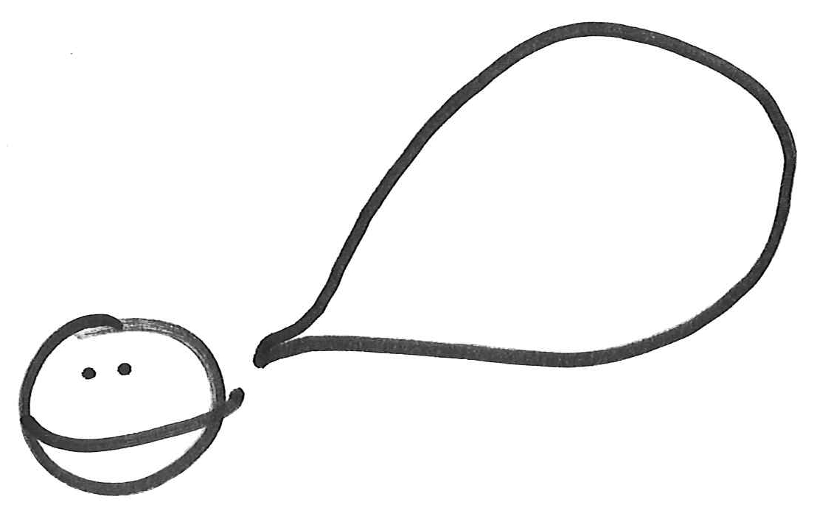
Would you work on making your writing sound more like you? The best way to do that is to do what you just did—say aloud what you want to write, and say it like you are talking to another person. Then put those words onto the paper.
Elaboration
Sometimes it seems to me that you are about to write really long and hard words, and then you start thinking, “Oh no, maybe I won’t spell them right. Oh no, maybe I’ll make a mistake, Oh no, Oh no.” (I’ve meanwhile been shaking in my boots.) When you feel like you might chicken out because you are worried about making a mistake—say to yourself, “Stop it! Be brave!” And then, even though you aren’t sure, just try the best you can and keep going. That’s the way to get the best writing onto the page.  If you chicken out from writing big words, or from writing the little details that can help a reader, or from trying to say something in a really beautiful way, your writing ends up just being so-so. The only way to make great writing is to be a brave writer.  continued Language |  | Be Brave!  Think about the parts of the word as you spell.  pumpkin  pump/kin  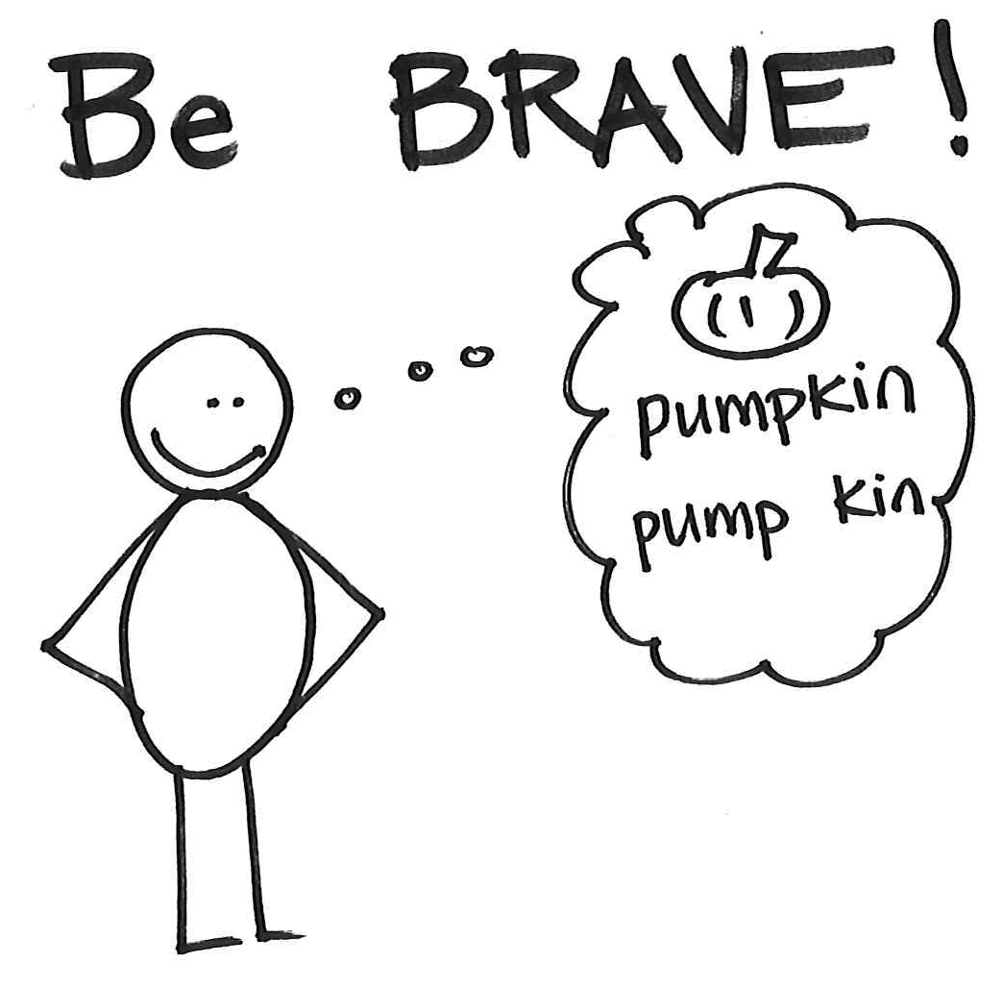
And to be a brave writer of long and hard words, you can think about each part of the word and think if you know other words that sound the same as that one.
You can even try the same word a couple of times. Then you can pick the one that sounds the best and looks right.
Language
Writers make lists in their writing to tell the reader lots of information. And they separate the items in their lists by using commas rather than writing a bunch of sentences (or using the word and).  One way to do this in your own writing is to think about the list of information that goes with your topic. Write each thing and then put a comma after each thing to separate the items in your list.  For example, “Central Park is the best park to visit in NYC. It has [now comes the list] playgrounds, fishing, gardens, and fields.”  Language  Language |  | An example to help her remember to reread and think about using commas when making a list in her writing.  “Central Park is the best park to visit in NYC. It has playgrounds, fishing, gardens, and fields.”  You may decide to highlight the commas or direct arrows under them to draw awareness.
I want to tell you something about your writing. You tend to write with big general words, and it is usually better to write with exact words. Like instead of saying, “Our coat closet is bad,” it would be better to say it with exact words. “Our coat closet is . . .” What? Messy? A snarl of coats? It looks like people just throw things anywhere? You see how it is better to use exact words than big general words like, “It is bad.”  Try asking yourself, “What exactly do I want to say?” Think about one way to say it, and then think about another way.  Language |  | What exactly do I want to say?  Think about one way . . . then think about another way!  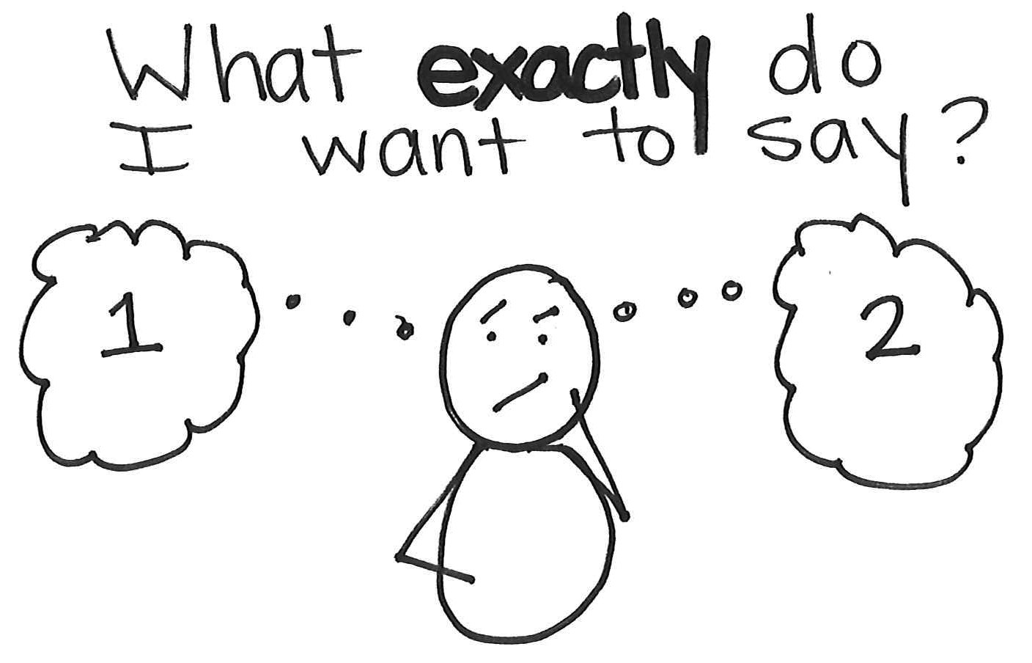
Writers can find ideas all around them.  In fact, one thing that you can do as a writer, right now, is look around this classroom. What things do you see, what problems are there, or what things could you make better?  Looking around you, whether you are in school, at home, or in the community, you can always find things to write about.  The Process of Generating Ideas |  | You may help the writer generate a list. Write these ideas down on a Post-it.
You are writing a lot of fast pieces. Yesterday you wrote three pieces in one day. Congratulations. Are you ready for the next challenge?  Because once you can do that—once you can come up with an idea and write it quickly—the next challenge is to come up with an idea, and not write about it. Instead, you think of another, another, and you list them across your fingers. Then you choose the very best idea, and work on that piece of writing for a really long time to make it the longest and the best piece you ever wrote. Are you willing to try that?  So first: list possible ideas.  Then: choose one.  Then: write the best piece you ever wrote in your whole life.  The Process of Generating Ideas |  | First: list possible ideas.  Then: choose one.  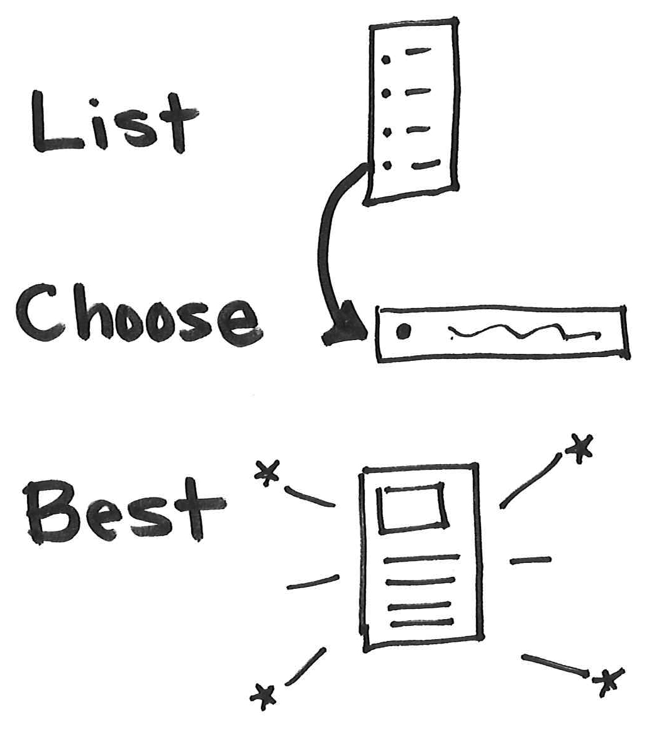  Then: write the best piece you ever wrote in your whole life.
One thing I notice about you is that when you write, you sit down at your desk, pick up your pen, and you get started. Lots of kids wait and wait and wait to think up an idea, but you don’t wait. Ideas come to you right away, and that is great.  continued  But I want to teach you that when an idea comes to you, it is good to not get started writing but to instead spend some time getting ready. The way writers get ready is they plan what they are going to say so that before they write a word, they have a whole lot of ideas for what will go at the beginning of the piece, and in the middle . . .  The Process of Drafting |  | A Post-it that helps to remind him how to get words down on the page. You may write, “Use your plan.” There may be an icon of a page of writing with picture space and writing space. There should be an arrow pointing to the picture space for the writer to use to help add to his words.  Planning paper—two pages taped together, divided into four columns that are labeled:  Problem  Fixing it, step 1  Fixing it, step 2  The solution
I think it would help you plan your opinion pieces if you did some drawings before you start writing—planning drawings. Maybe you could try starting with a drawing of the problem, then one or two drawings of what you think people could do, step 1 and step 2, to fix the problem, and then a drawing of what things will be like when they are fixed up.  So today, you are writing about the park being messy—what will go in the first drawing, the drawing about the problem? Okay—so beautiful birds and flowers and then garbage. Will you put some details in—like show a daffodil with a paper cup smooshed right on it? Great! Then that drawing will help you plan out about six things you can say about the problem!  The Process of Drafting  The Process of Drafting |  | 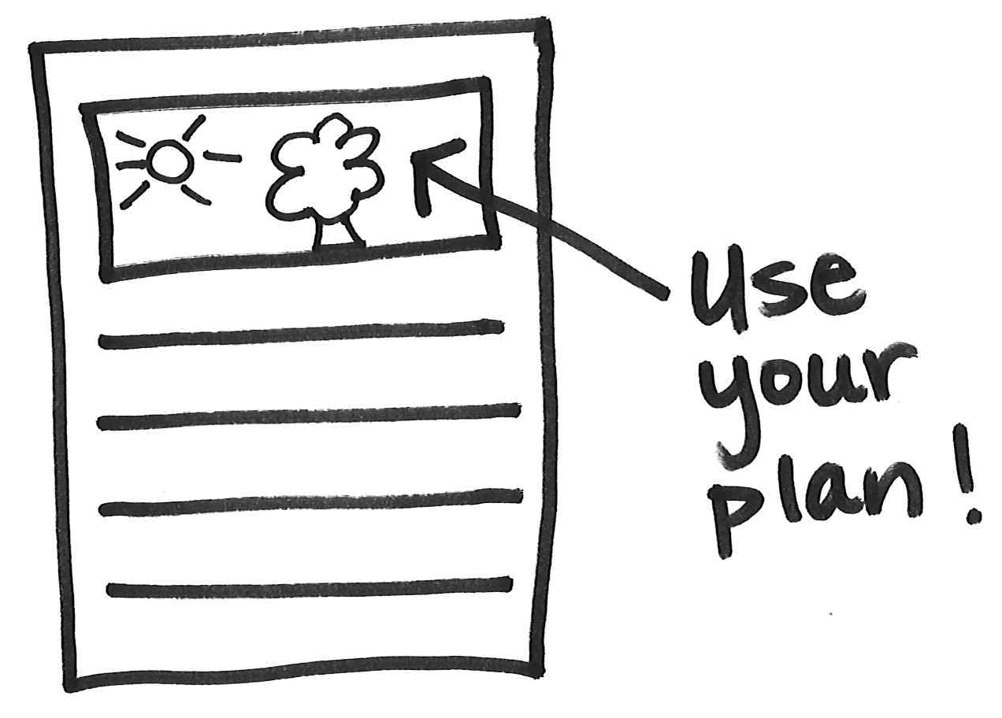
It seems like you get to the end of the page, when you are writing, and you stop there. But lots of times, I am pretty sure you have more to say—but you aren’t going to page 2, or adding on a flap at the ending.  After this, will you remember that writers write as much as they have to say . . . and they make their books longer, their pages longer, so they can say everything? They ask themselves, “Do I have more to say?” And if they have more to say, they find the space. They make the space.  Whenever you want to add more, you can think, “Should I add a flap or a whole new page?” And then just tape or staple it in!  The Process of Revision |  | Extra flaps and strips to use and add onto her page.  To help the writer to remember to use these tools again the next day, you may tuck a few into her writing folder. This way, as she is trying to add more, she will have a few flaps ready to add on.  You may leave a Post-it that reminds her to add on to her writing. It may say, “Revise” at the top, and underneath it may say, “Add on information, examples, and reasons.”
I notice that you elaborate by (strategy the writer is using) in your opinion books, and that is great. BUT writers try to write with a variety of stuff. So I wanted to remind you that opinion writers also say more by adding in these things:  - Tips on how to do something  - Suggestions on the best ways to do something  - Warnings about what could go wrong  - Stories of other people who have done this  - Encouragement to do this  Let’s reread your piece and think about which ones we can add.  The Process of Revision |  | If you made a whole-class chart on ways to elaborate in opinion writing, you could make a mini version of that chart for the child’s writing folder, or you could turn that chart into a checklist.
Writers reread their writing and revise their pieces to make sure that the details and information they are giving fit with their opinions.  One way you can check for this is you can reread your piece and ask yourself, “Do the information and reasons go with my opinion?” If they don’t, you can cross them out.  The Process of Revision |  | A chart that on one side says, “Fits with my information,” and on the other side says, “Does not fit with my information.”
When writers edit, there are many things that they look for and try to fix.  You can use a checklist to help you think about editing for many things.  You may want to reread your piece a few times, looking for different things each time.  The Process of Editing |  | Reread and Edit!  - Spelling  - Punctuation  - Capitals
Young writers use more than one strategy to spell.  As you are spelling a word, you can try to think about what is the best way to spell this word—the word wall, trying to write and rewrite the word a few times, or looking it up in a resource in the room.  The Process of Editing |  | Try Different Spellings:  1. _________________________  2. _________________________  3. _________________________

